Code Magnets

***thinking computationally***

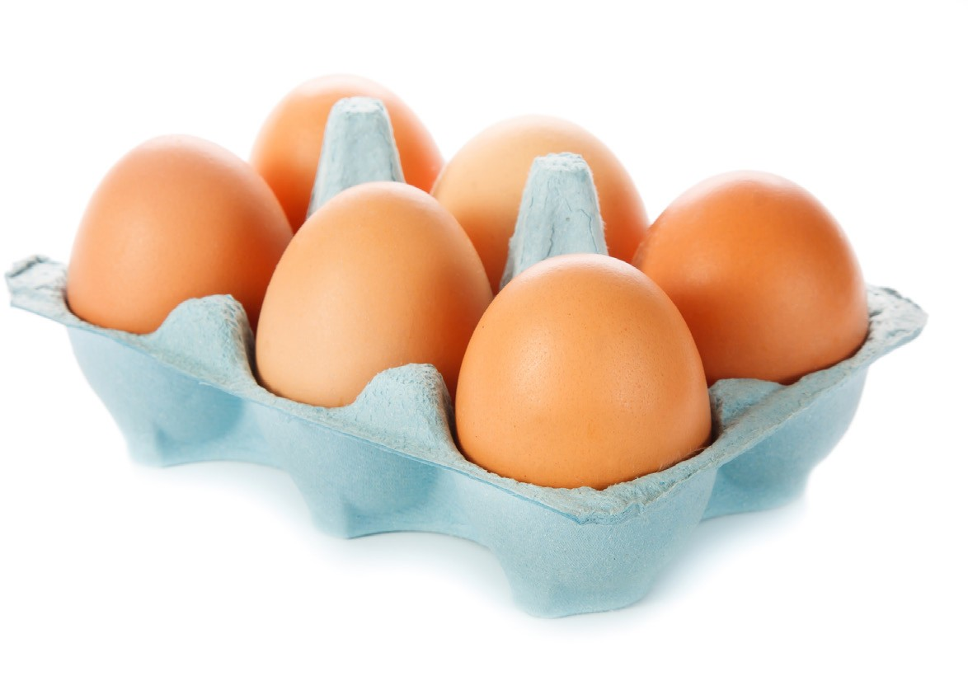

Let’s get a little practice with ~~recipes~~ algorithms. We put the Head First Diner’s algorithm for making an three-egg omelet on the fridge to remember it, but someone came along and messed it up. Can you put the magnets back in the right order to make our algorithm work? Note that the Head First Diner makes two kinds of omelets: plain and cheese. **Make sure you check your answer at the end of the chapter.**

Rearrange these magnets here

to make the algorithm work.

Steps/Algorithm:

1. Crack three eggs into a bowl

2. Whip eggs

3. Heat saute pan

4. Transfer eggs to pan

5. while eggs aren’t fully mixed:

- Stir eggs

6. If customer ordered cheese:

While eggs aren’t fully cooked:

+ add cheese on

7. Remove pan from heat

8. Transfer eggs to plate

9. Serve

**Transfer eggs to plate**

**While**

**eggs aren’t fully**

**cooked:**

**Serve**

**Heat saute pan**

***you are here*** ► 5